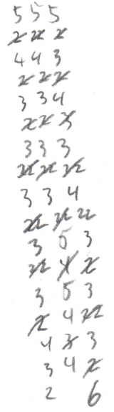
The Margin Game
In every body of printed text there exists a "margin," a thin expanse of blank paper between the text and the edge of whatever it's printed on. What a waste of paper! Wouldn't it be neat if this throwaway space could be used for something?

Preparation
To play the margin game, you need a pencil/pen, a book, and optionally a blank sheet of paper if you don't want to write in the book. The "book" can be an actual book, tax filing instructions, the back of a cereal box, or anything containing multiple paragraphs of text.

How to Play
The goal of the margin game is to fill the margin of the page from top to bottom with numbers. The numbers are arranged in three columns, and are added according to the following rules:
- Each column starts with a 5, so the game starts with three 5s in a row at the top of the margin.
- Each new number is the count of syllables in the next word of the text, skipping single-syllable words. For example, the sentence "According to all known laws of aviation, there is no way a bee should be able to fly" produces the numbers 3, 4, and 2 in that order.
- A number may be added to any column as long as the number is strictly less than the most recent number added to that column (the bottom-most number). For example, the number 3 may be added to any column that ends in a 4 or 5, but not to a column which ends in a 2 or 3.
- If the sum of the numbers in a column is greater than four, then at any time you may cross out the most recent number in the column. This resets the sum in the column to zero and means that any number may be added to the column regardless of its value. For example, in a column with the numbers 3 and 2 the sum is five, which is greater than four. If we want to add a 3 to the column then we can do so by first crossing out the 2. After adding the 3, the new sum is only three, so more numbers will need to be added to the column before another cross-out is possible.
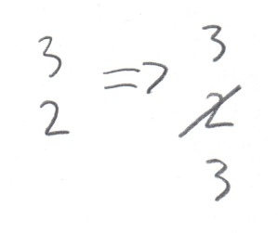
- The number 2 is special. A column is allowed to contain two 2s in the same slot by writing them next to one another as though they were the number 22. Both twos count towards the sum, making a "double two" equivalent to a four.
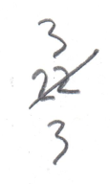
- At any time you may skip a word and come back to it later. Keep track of these words by circling them, then cross them out once you've finally added them. If you don't want to mark up the text, you can instead track skipped words by noting the number of skipped syllables using an extra column or two.

The game is won when all three columns reach the bottom of the page or you run out of words. The game is lost when there are still words to add but no place to put them.
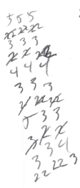
Cheating
Writing styles vary too much for these rules to apply equally well to all documents, so bending the rules/cheating is encouraged. If you don't know how to count the syllables in a particular word, then just count them in the way that's most advantageous. If twos start piling up then increase the double-two rule to a triple-two rule, or add a rule that you can nuke all skipped two-syllable words for every new five-syllable word.
The base rules should work well on highly polysyllabic documents so hopefully no cheating should be necessary for things like bank statements, contracts, legal notices, old-timey flowery prose, etc.

Reminder
It shouldn't need to be said, but please don't write in a book you don't actually own. The margin game is not something you should play by scribbling in the margins of books borrowed from a school or local library.

